CLASS 7 | COMPUTER SCIENCE
Communication with AI
Hello Python, Code Your First Idea
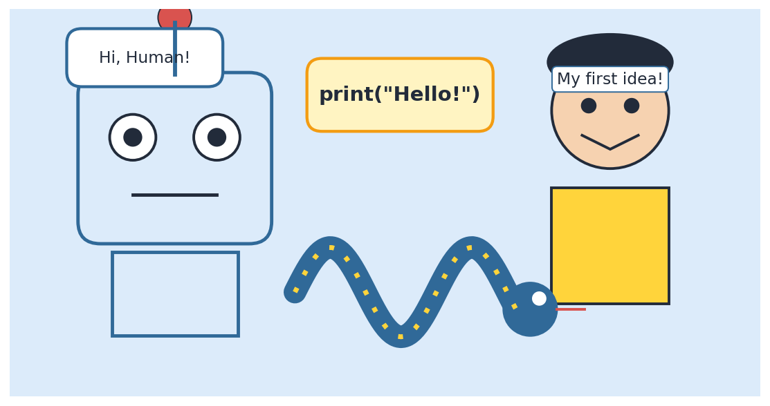
Student Notes with Theory, Examples, Diagrams and Practice
Name: ____________________ Section: ________ Roll No.: ______
Contents
Chapter 1 Talking to Computers
Chapter 2 What is Artificial Intelligence?
Chapter 3 Communicating with AI: Prompts
Chapter 4 Meet Python
Chapter 5 Setting Up Python
Chapter 6 Hello, World! Your First Program
Chapter 7 Rules of Python and Fixing Mistakes
Chapter 8 Variables and Data Types
Chapter 9 Talking to Your Program: Input
Chapter 10 Operators: Python as a Calculator
Chapter 11 Making Decisions: if, elif, else
Chapter 12 Loops: Repeating Without Rewriting
Chapter 13 Lists: Storing Many Values
Chapter 14 Functions: Reusable Mini-Programs
Chapter 15 From Idea to Code
Chapter 16 Mini Projects: Code Your First Ideas!
Chapter 17 Python and AI Working Together
Chapter 18 Debugging: Becoming a Bug Detective
Chapter 19 Revision, Glossary and Practice
How to use these notes
- Read each chapter slowly and look at every picture.
- Type every program yourself. Do not just read it!
- Complete the "Try It Yourself" boxes.
- Finish the practice questions in Chapter 19.

Chapter 1 Talking to Computers

1.1 What is Communication?
Communication means sharing information, ideas or feelings with someone. When you speak to your friend, write a letter, send a message or even wave your hand, you are communicating. For communication to work, we need three things: a sender (the one who gives the message), a message, and a receiver (the one who gets the message).
Communication works only when both sides understand the same language. If you speak Tamil and your friend knows only French, the message will not be understood. Computers also have their own languages!

1.2 How Does a Computer Work?
A computer is a machine that follows instructions. It cannot think on its own like humans. Every computer works in three simple steps: Input → Process → Output.
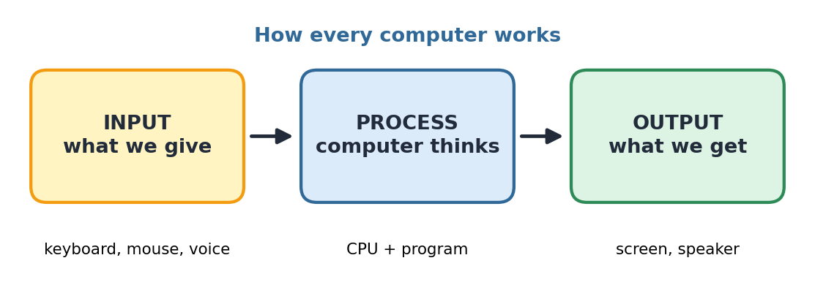
Figure 1.1: The Input–Process–Output cycle
- Input: the data we give to the computer, for example typing on a keyboard, clicking a mouse or speaking into a microphone.
- Process: the computer works on the data using its brain, the CPU, and a program (a set of instructions).
- Output: the result shown to us on the screen, printer or speaker.

1.3 Human Language vs. Computer Language
Humans use languages like Tamil, English and Hindi. Computers understand only electric signals, which we write as 0s and 1s (called binary). Writing everything in 0s and 1s is very difficult for people. So, clever scientists created programming languages such as Python, Scratch, Java and C. These languages are like a bridge between humans and computers.
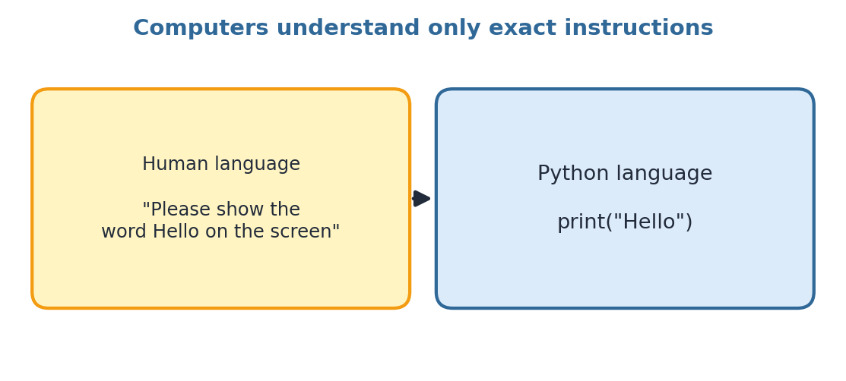
Figure 1.2: Humans use natural language; computers need exact instructions
A program is a set of step-by-step instructions written in a programming language to make a computer do a task. The person who writes programs is called a programmer or coder.
Human Language | Programming Language
Can be flexible and have many meanings | Must be exact and clear
Small mistakes are usually okay | A small mistake can stop the program
Understood by people | Understood by computers (after translation)
Example: "Show Hello" | Example: print("Hello")

★ Key Points
Communication needs a sender, a message and a receiver.
Computers follow instructions: Input → Process → Output.
A programming language lets us talk to a computer.
Python is one of the easiest programming languages to start with.

Chapter 2 What is Artificial Intelligence?

2.1 Meaning of AI
Artificial Intelligence (AI) is the ability of a machine or computer program to do tasks that normally need human intelligence, such as understanding speech, recognising faces, making decisions and answering questions. The word artificial means made by humans, and intelligence means the ability to learn and understand.
Think about how you learned to recognise a mango. Someone showed you many mangoes and told you the name. After seeing many examples, you could identify a mango easily. AI learns in a similar way, but it needs thousands or even millions of examples. These examples are called data.
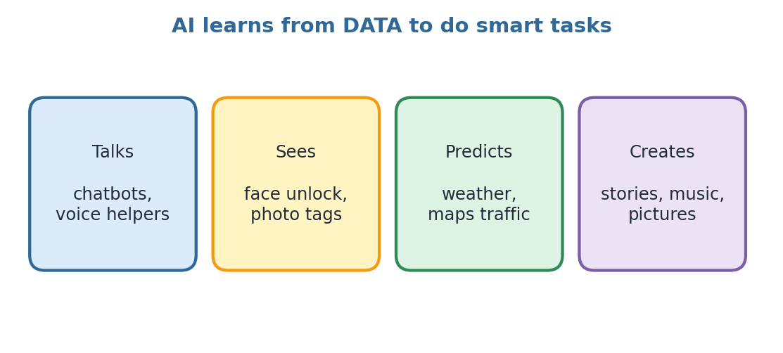
Figure 2.1: Things AI can do

2.2 How Does AI Learn?
- Collect data: pictures, text, sounds or numbers are collected.
- Train: the computer studies the data and finds patterns.
- Test: we check whether the AI gives correct answers.
- Use: people use the trained AI in apps and devices.
This kind of learning is called Machine Learning (ML): the machine learns from examples instead of being told every rule.

2.3 AI Around Us
Where we see AI | What it does
Voice assistants (Google Assistant, Alexa) | Understand your voice and answer
Maps and navigation | Predict traffic and find the fastest route
YouTube / OTT suggestions | Recommend videos you may like
Phone camera | Detects faces and improves photos
Chatbots (like Claude) | Chat with you in natural language
Online translators | Convert one language to another

2.4 Is AI Like a Human Brain?
No. AI is a powerful tool, but it does not have feelings, family or real understanding like humans. It can make mistakes, and it only knows what it has learned from data. That is why humans must always check important answers given by AI.
☺ Fun Fact
The word "Artificial Intelligence" was first used in the year 1956 at a college meeting in the USA. Today, billions of people use AI every day without even noticing!

★ Key Points
AI is a machine's ability to do smart tasks.
AI learns from data using machine learning.
AI is a helper; humans stay in charge.

Chapter 3 Communicating with AI: Prompts

3.1 What is a Prompt?
When you chat with an AI assistant, the text you type is called a prompt. A prompt is simply your instruction or question to the AI. The answer you receive is the response. The better your prompt, the better the response!
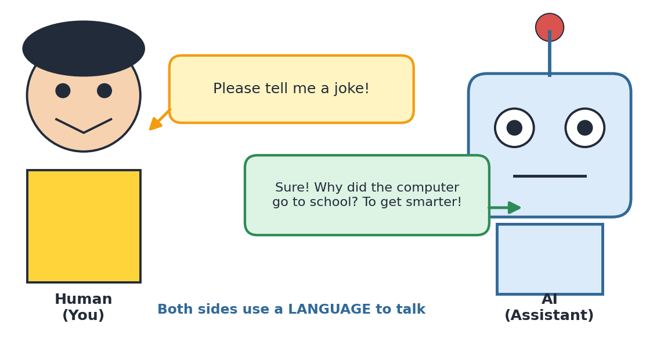
Figure 3.1: You send a prompt and the AI sends back a response

3.2 Parts of a Good Prompt
A clear prompt usually has four parts:
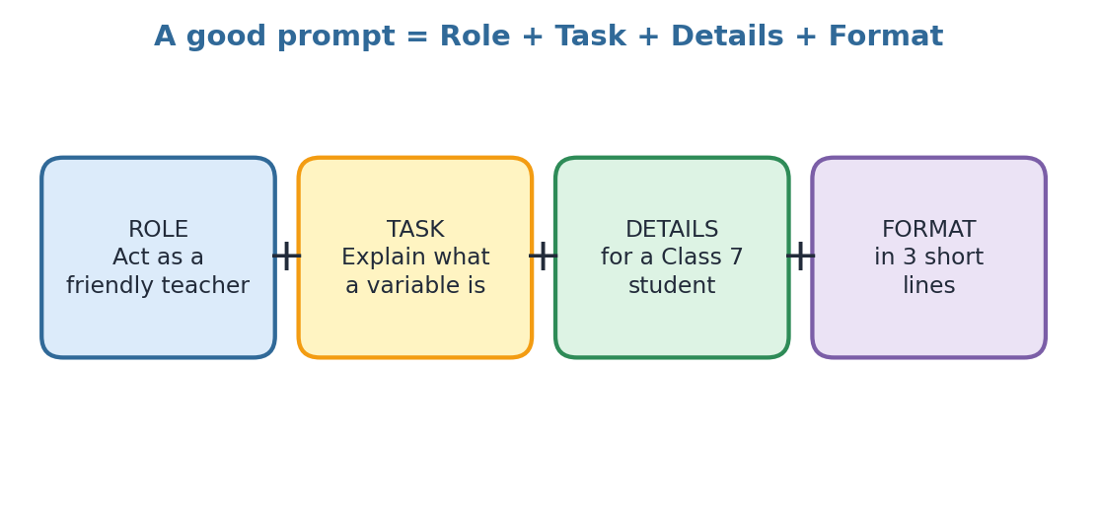
Figure 3.2: Role + Task + Details + Format
Weak Prompt | Strong Prompt
Tell me about Python. | Explain what Python is to a Class 7 student in 5 simple lines.
Make a quiz. | Make a 5-question multiple-choice quiz on variables in Python with answers.
Fix my code. | My code print("Hi" shows an error. Explain the mistake in simple words and show the corrected line.

3.3 Tips for Talking to AI
- Be clear and specific. Say exactly what you want.
- Give context: tell your class, your topic and your goal.
- Ask for steps or examples if you are confused.
- If the answer is not right, ask again with more details. This is called refining your prompt.
- Always be polite and respectful. Good habits stay with you everywhere.

3.4 Using AI Safely
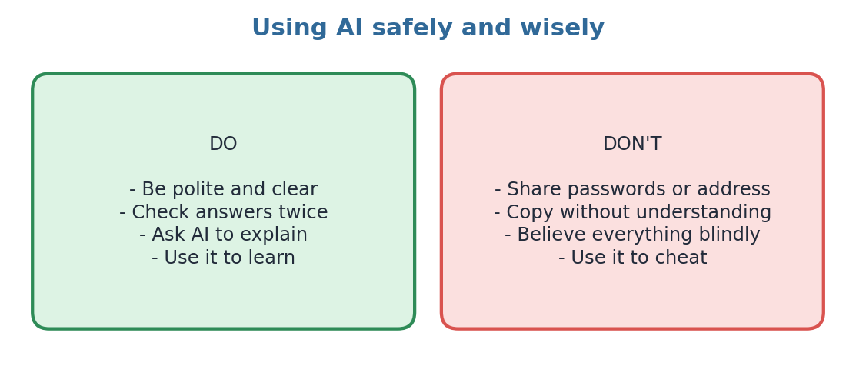
Figure 3.3: Do's and Don'ts when using AI
! Remember
Never share your password, phone number, home address or photos with any AI tool or website. AI can give wrong answers, so always verify with your teacher, textbook or parents.

✎ Try It Yourself
Write a strong prompt asking AI to explain "What is a computer virus?" for your age group. Use Role + Task + Details + Format.

Chapter 4 Meet Python

4.1 What is Python?
Python is a popular, easy-to-read programming language used by students, scientists and big companies around the world. It was created by a Dutch programmer named Guido van Rossum. He started working on it in 1989 and released it in 1991.
Many people think Python is named after a snake, but it was actually named after a British comedy show called Monty Python's Flying Circus. That is why the Python logo and mascots are often shown with a snake!
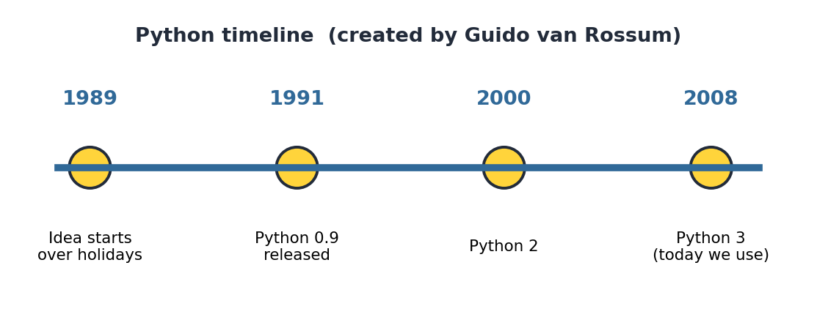
Figure 4.1: History of Python

4.2 Why Learn Python?
- Easy to read: Python code looks almost like English.
- Easy to write: you need fewer lines than many other languages.
- Free and open source: anyone can download and use it.
- Works everywhere: Windows, Mac, Linux and even small computers like Raspberry Pi.
- Huge community: millions of helpers and ready-made tools called libraries.
- Perfect for AI: most AI tools in the world are built with Python.

4.3 Where is Python Used?
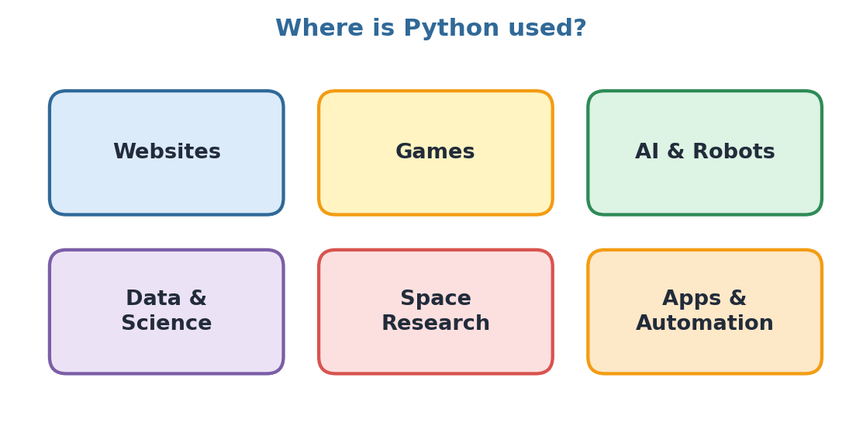
Figure 4.2: Fields where Python is used
Websites like Instagram and YouTube use Python in parts of their systems. Scientists use it to study space data, and engineers use it to control robots. Python also helps build the AI chatbots we use every day.

4.4 Python is Interpreted
Computers understand only machine language. A special program called an interpreter reads our Python code line by line and translates it for the computer. If there is a mistake, the interpreter stops and tells us which line has the problem. This makes finding errors easier for beginners.
★ Key Points
Python was created by Guido van Rossum in 1989–1991.
It is simple, free and powerful.
It is used in AI, games, websites, science and robots.
Python uses an interpreter that runs code line by line.

Chapter 5 Setting Up Python: Your Coding Workshop

5.1 What Do We Need?
To write Python programs we need two things: the Python interpreter (to run the code) and a code editor (a notepad for writing code). Many editors give both in one package.
Tool | Details
IDLE | Comes with Python. Simple and good for beginners.
Thonny | Free, clean editor made for students.
Online editors | Run Python in a web browser with no installation (for example, Replit or Google Colab).
Mobile apps | Apps like Pydroid let you code on a tablet or phone.

5.2 Two Ways to Run Python

(a) Interactive Mode
You type one line at a time after the prompt >>> and press Enter. Python answers immediately. It is like chatting with Python!
Interactive mode
>>> 5 + 3
8
>>> print("Hi!")
Hi!

(b) Script Mode
You write many lines in a file and save it with the extension .py, for example hello.py. Then you run the whole file at once. We use script mode for longer programs.
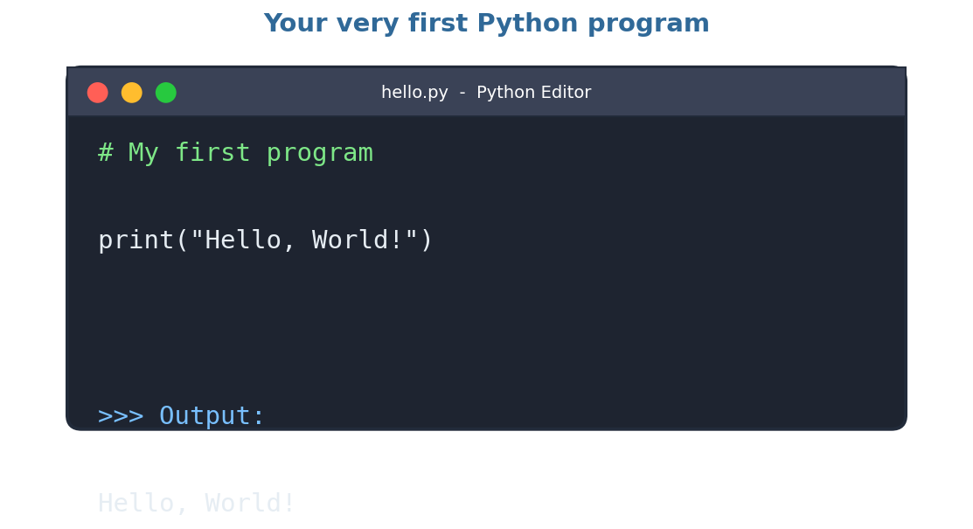
Figure 5.1: A Python file in an editor, and its output

5.3 Steps to Write and Run Your First Program
- Open Python IDLE or Thonny (or an online editor).
- Create a new file (File → New File).
- Type your code carefully.
- Save the file with a name ending in .py.
- Click Run (or press the F5 key) to see the output.
! Remember
Python is case-sensitive. print works, but Print or PRINT will give an error. Also check every bracket and quotation mark!

✎ Try It Yourself
Open interactive mode and type 2 + 2, then 10 * 5. What does Python say?

Chapter 6 Hello, World! Your First Program

6.1 The Famous First Program
Every programmer in the world starts with the same tiny program that shows the words "Hello, World!" on the screen. Today it is your turn!
Program 1
print("Hello, World!")
OUTPUT
Hello, World!

Congratulations! You are now a Python programmer. Let us understand each part of this line.
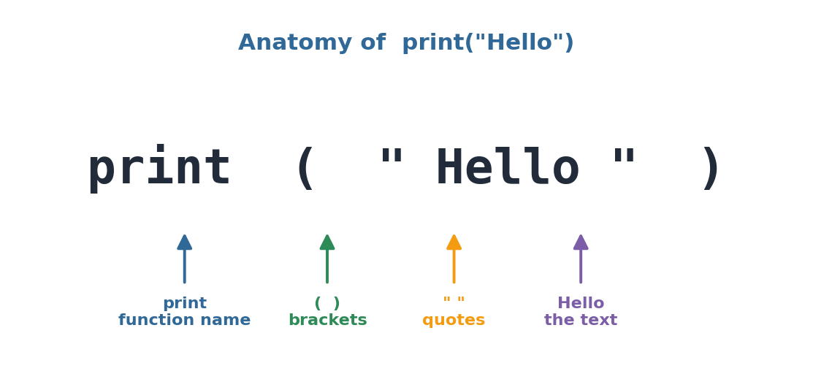
Figure 6.1: Parts of a print statement
- print is a built-in function. A function is a ready-made helper that does a job. Here, the job is to display something.
- ( ) The round brackets hold what we want to show.
- " " Quotation marks tell Python that the content inside is plain text (called a string). You may use single quotes ' ' too.

6.2 Printing Many Lines
Program 2
print("Hello!")
print("My name is Python.")
print("Let's be friends.")
OUTPUT
Hello!
My name is Python.
Let's be friends.

Python runs the lines one after another, from top to bottom. This is called sequential execution.

6.3 Printing Numbers and Calculations
Numbers do not need quotation marks. Python can also do math inside print.
Program 3
print(25)
print(10 + 5)
print("10 + 5")
OUTPUT
25
15
10 + 5

Notice that "10 + 5" in quotes is treated as text, so Python does not calculate it.

6.4 Special Characters (Escape Sequences)
Code | Meaning | Example
\n | Go to a new line | print("Hi\nBye")
\t | Add a tab space | print("A\tB")
\" | Print a quotation mark | print("He said \"Hi\"")

6.5 Comments: Notes for Humans
A comment is a note that Python ignores. It starts with the # symbol. Comments help us and others understand the code.
Program 4
# This program greets the world
print("Hello") # this line shows Hello

6.6 Printing More Than One Item
Program 5
print("Python", "is", "fun")
print("Age:", 12)
OUTPUT
Python is fun
Age: 12

★ Key Points
print() shows output on the screen.
Text goes inside quotation marks; numbers do not need them.
# starts a comment, which Python ignores.
Python runs code from top to bottom.

✎ Try It Yourself
Write a program that prints your name, your school and your favourite game on three separate lines.

Chapter 7 Rules of Python and Fixing Mistakes

7.1 Syntax: The Grammar of Python
Just like English has grammar rules, Python has rules called syntax. If we break the rules, Python shows an error message. Do not be afraid of errors. Even expert programmers make mistakes every day. Errors simply guide us to fix our code.

7.2 Important Rules
- Python is case-sensitive: Name and name are different.
- Every opening bracket ( needs a closing bracket ).
- Every opening quotation mark needs a closing quotation mark.
- Words like print, if, for are keywords with special meanings, so we cannot use them as names of our own things.
- Indentation (spaces at the beginning of a line) matters in Python.
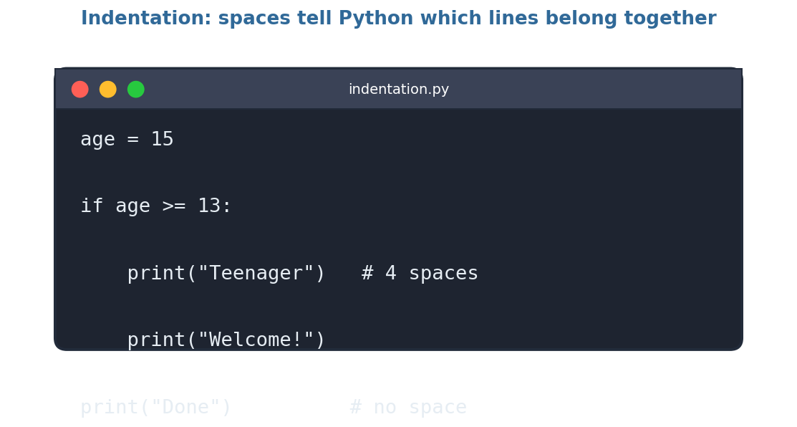
Figure 7.1: Indented lines belong to the if block

7.3 Kinds of Errors
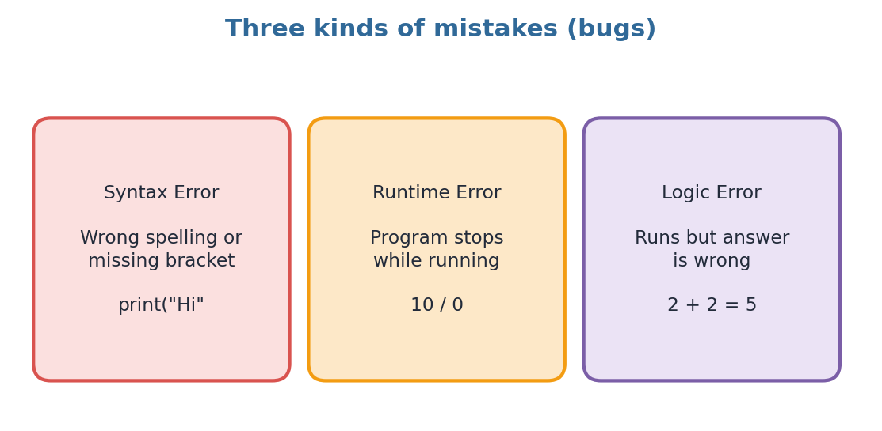
Figure 7.2: Syntax, runtime and logic errors
Error type | When it happens | Example
Syntax error | Rules are broken; program will not start | print("Hi" (missing bracket)
Runtime error | Program starts but crashes in the middle | print(10 / 0)
Logic error | Program runs but gives a wrong answer | Using + instead of *

7.4 Reading an Error Message
Wrong code
print("Hello)
OUTPUT
SyntaxError: unterminated string literal
(the closing quotation mark is missing)

The message tells us the type of error and the line number. Read it slowly. It is like a hint from Python!
! Remember
The mistake is often in the line shown or the line just before it. Check brackets, quotes and spelling.

✎ Try It Yourself
Find and fix the mistakes: (a) Print("Hi") (b) print("Good morning) (c) print(Hello)

Chapter 8 Variables and Data Types

8.1 What is a Variable?
A variable is a named container that stores a value in the computer's memory. Imagine a box with a label. The label is the variable name and the thing inside is the value. We can look at the value or change it whenever we want.
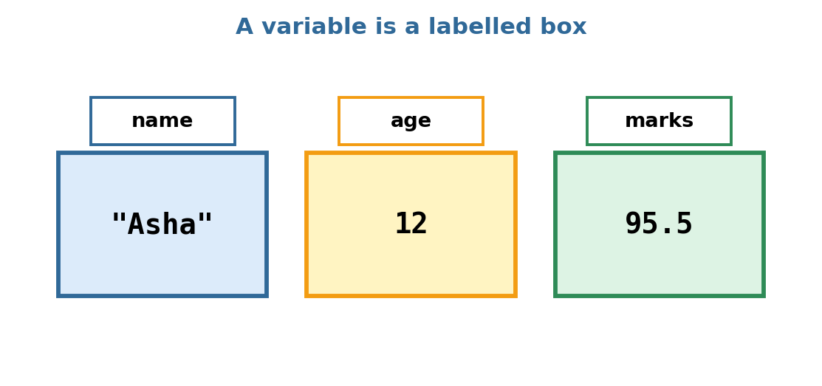
Figure 8.1: Variables are labelled boxes holding values
Program 6
name = "Asha"
age = 12
marks = 95.5
print(name)
print(age)
print(marks)
OUTPUT
Asha
12
95.5

The = sign here is called the assignment operator. It does not mean "equal" like in maths. It means "store the value on the right inside the variable on the left".

8.2 Rules for Naming Variables
Rule | Good name | Bad name
Use letters, digits and underscore only | total_marks | total-marks
Cannot start with a digit | score1 | 1score
No spaces allowed | my_age | my age
Cannot be a keyword | count | if
Upper and lower case are different | Name and name are two variables

Choose names that explain themselves. price is better than p, because anyone reading the code understands it.

8.3 Changing a Variable
Program 7
score = 10
print(score)
score = 25
print(score)
OUTPUT
10
25

When we store a new value, the old value is replaced. That is why it is called a variable: it can vary (change)!

8.4 Data Types
Every value in Python has a data type, which tells Python what kind of value it is.
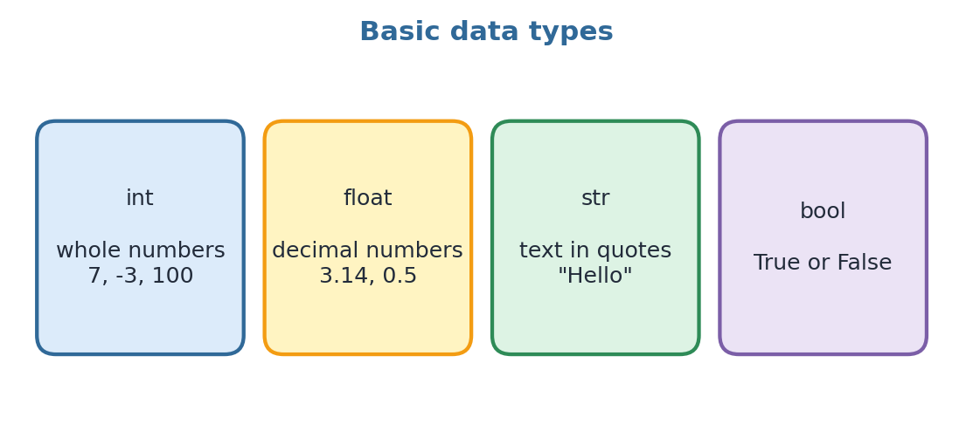
Figure 8.2: Four basic data types
Program 8
print(type(7))
print(type(3.14))
print(type("Hello"))
print(type(True))
OUTPUT
<class 'int'>
<class 'float'>
<class 'str'>
<class 'bool'>

☺ Fun Fact
Python decides the data type by itself. In many other languages, programmers must write the type first. This is one reason Python is called beginner-friendly.

★ Key Points
A variable stores a value using the = sign.
Names must follow the naming rules.
Common data types: int, float, str and bool.
type() tells us the data type of a value.

Chapter 9 Talking to Your Program: Input

9.1 The input() Function
So far, our programs only talk. Now let us make them listen! The input() function asks the user to type something and waits. Whatever the user types is stored in a variable.
Program 9
name = input("What is your name? ")
print("Hello,", name)
OUTPUT
What is your name? Ravi
Hello, Ravi

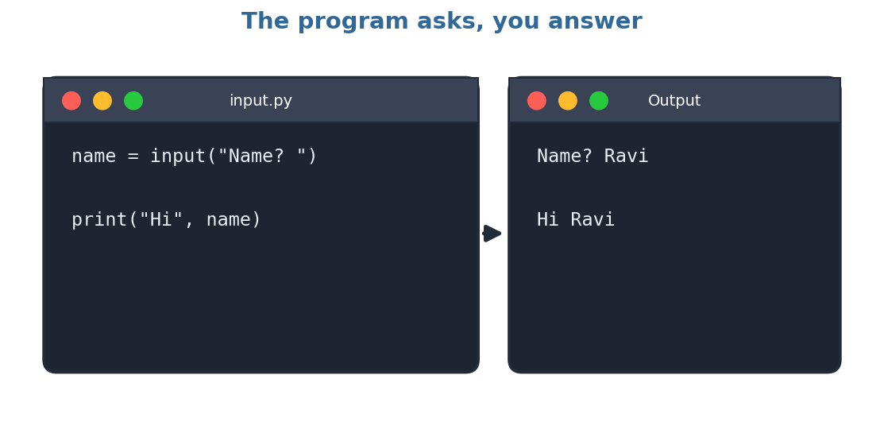
Figure 9.1: input() asks and the user answers
The text inside input( ) is called the prompt message. It tells the user what to type. (Do you remember prompts from Chapter 3? Same idea!)

9.2 Input is Always Text
Important: input() always gives us a string, even if the user types a number. To do maths, we must convert it using type conversion:
Function | Converts to | Example
int() | Whole number | int("12") gives 12
float() | Decimal number | float("2.5") gives 2.5
str() | Text | str(45) gives "45"

Program 10: Adding two numbers
a = int(input("First number: "))
b = int(input("Second number: "))
print("Sum =", a + b)
OUTPUT
First number: 8
Second number: 4
Sum = 12

9.3 f-Strings: Easy Messages
An f-string lets us place variables inside a sentence. Put the letter f before the quotes and write variable names inside curly brackets { }.
Program 11
name = input("Name: ")
age = int(input("Age: "))
print(f"{name} will be {age + 1} next year!")
OUTPUT
Name: Meera
Age: 12
Meera will be 13 next year!

! Remember
If you forget int() and add two inputs, Python joins them as text: "8" + "4" gives "84", not 12!

✎ Try It Yourself
Write a program that asks for the length and breadth of a rectangle and prints its area.

Chapter 10 Operators: Python as a Calculator

10.1 Arithmetic Operators
An operator is a symbol that tells Python to perform an action. Python has many operators for maths.
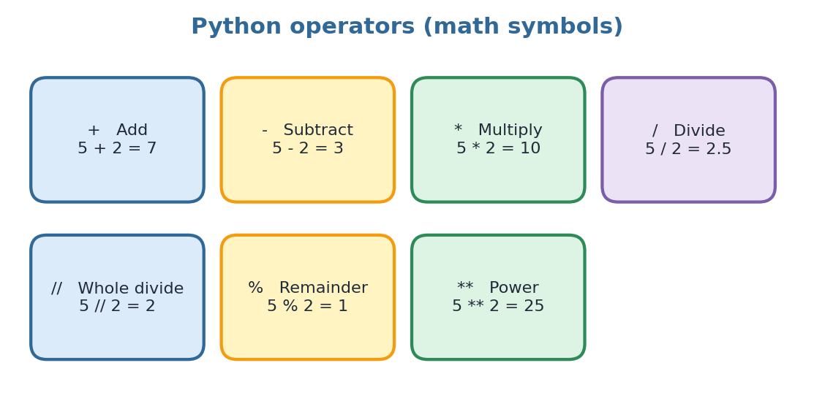
Figure 10.1: Arithmetic operators with examples
Program 12
a = 17
b = 5
print(a + b)
print(a - b)
print(a * b)
print(a / b)
print(a // b)
print(a % b)
print(a ** 2)
OUTPUT
22
12
85
3.4
3
2
289

- / always gives a decimal answer.
- // gives only the whole number part (floor division).
- % gives the remainder. It is very useful to check even and odd numbers: if n % 2 is 0, the number is even.

10.2 Order of Operations
Python follows the BODMAS rule: Brackets first, then powers, then multiplication/division, then addition/subtraction.
Program 13
print(2 + 3 * 4)
print((2 + 3) * 4)
OUTPUT
14
20

10.3 Comparison Operators
These operators compare two values and give the answer True or False.
Operator | Meaning | Example | Result
== | Equal to | 5 == 5 | True
!= | Not equal to | 5 != 3 | True
> | Greater than | 3 > 8 | False
< | Less than | 3 < 8 | True
>= | Greater than or equal | 7 >= 7 | True
<= | Less than or equal | 9 <= 4 | False

! Remember
A single = stores a value. A double == compares two values. Do not mix them up!

10.4 Logical Operators
Operator | Meaning | Example
and | True only if both sides are True | age > 10 and age < 15
or | True if at least one side is True | day == "Sat" or day == "Sun"
not | Reverses True/False | not (5 > 3) is False

★ Key Points
Arithmetic operators: + - / // % *
Comparison operators give True or False.
Logical operators: and, or, not.
= stores, == compares.

Chapter 11 Making Decisions: if, elif, else

11.1 Why Do We Need Decisions?
In real life we make decisions all the time: If it rains, take an umbrella; otherwise, wear a cap. Programs also need to choose between different actions. We do this with conditional statements.

11.2 The if Statement
Program 14
age = 15
if age >= 13:
print("You are a teenager.")
OUTPUT
You are a teenager.

The line after if is a condition. If it is True, the indented lines run. If it is False, Python skips them. Do not forget the colon ( : ) and the indentation (4 spaces).

11.3 if ... else
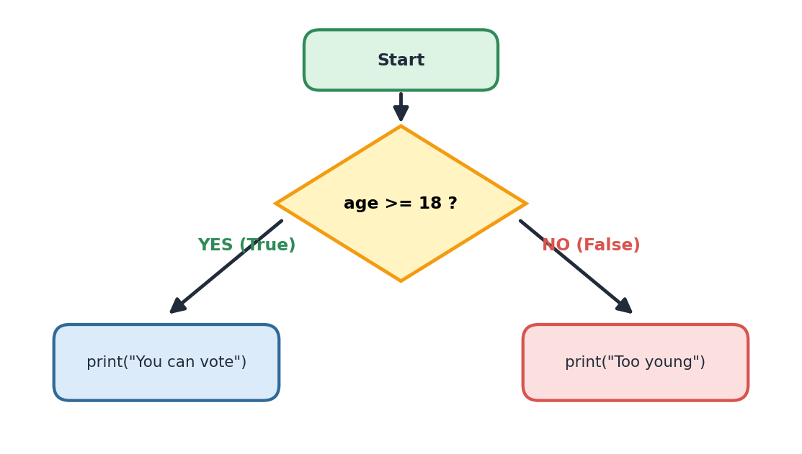
Figure 11.1: Flowchart of an if–else decision
Program 15
age = int(input("Enter your age: "))
if age >= 18:
print("You can vote.")
else:
print("You are too young to vote.")
OUTPUT
Enter your age: 20
You can vote.

11.4 if ... elif ... else
When there are many choices, we use elif (short for "else if").
Program 16: Grade checker
marks = int(input("Enter marks: "))
if marks >= 90:
print("Grade A")
elif marks >= 75:
print("Grade B")
elif marks >= 50:
print("Grade C")
else:
print("Try again!")
OUTPUT
Enter marks: 82
Grade B

Python checks the conditions from top to bottom and runs only the first one that is True.

11.5 Even or Odd
Program 17
n = int(input("Enter a number: "))
if n % 2 == 0:
print("Even number")
else:
print("Odd number")

★ Key Points
Use if for decisions, elif for more choices, else for everything left.
End each condition line with a colon ( : ).
Indent the lines that belong to the block.

✎ Try It Yourself
Write a program that asks for a number and says whether it is positive, negative or zero.

Chapter 12 Loops: Repeating Without Rewriting

12.1 Why Loops?
Suppose you want to print "Hello" five times. You could write five print lines, but what if you needed a thousand? A loop repeats instructions again and again so that we write them only once. Computers are great at repeating tasks without getting tired!
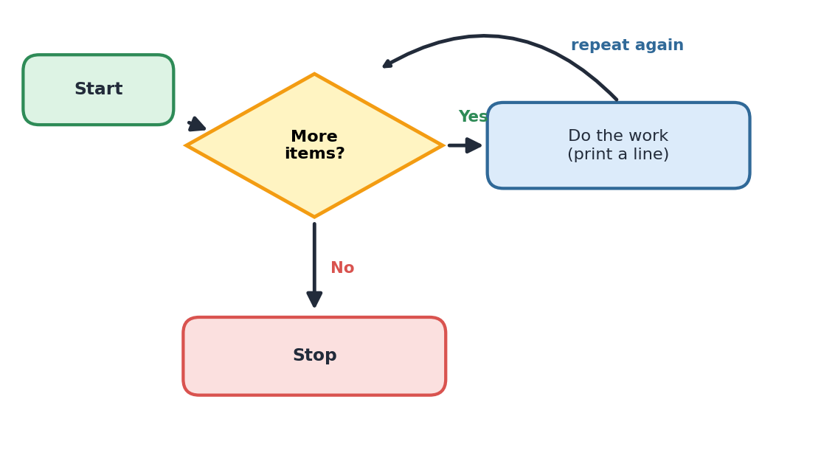
Figure 12.1: A loop keeps repeating until the condition ends

12.2 The for Loop
Program 18
for i in range(5):
print("Hello", i)
OUTPUT
Hello 0
Hello 1
Hello 2
Hello 3
Hello 4

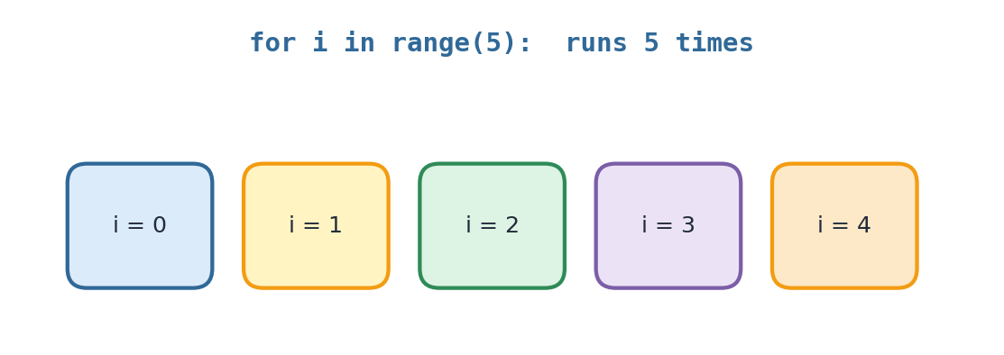
Figure 12.2: range(5) gives 0, 1, 2, 3, 4
range(5) makes the numbers 0 to 4 (it stops before 5). We can also write range(start, stop) or range(start, stop, step).
Program 19
for n in range(1, 6):
print(n)

for n in range(2, 11, 2):
print(n)
OUTPUT
1 2 3 4 5 (printed on separate lines)
2 4 6 8 10 (printed on separate lines)

12.3 Multiplication Table
Program 20
num = int(input("Table of: "))
for i in range(1, 11):
print(num, "x", i, "=", num * i)
OUTPUT
Table of: 5
5 x 1 = 5
5 x 2 = 10
...
5 x 10 = 50

12.4 The while Loop
A while loop keeps running as long as its condition is True.
Program 21
count = 1
while count <= 5:
print("Count:", count)
count = count + 1
print("Finished!")
OUTPUT
Count: 1
Count: 2
Count: 3
Count: 4
Count: 5
Finished!

! Remember
If the condition never becomes False, the loop never ends. This is called an infinite loop. Always make sure something inside the loop changes (like count = count + 1).

for loop | while loop
Use when we know how many times to repeat | Use when we repeat until something happens
Example: print a table up to 10 | Example: keep asking until the password is right

★ Key Points
Loops repeat code.
for ... in range() repeats a fixed number of times.
while repeats until its condition becomes False.
Beware of infinite loops!

Chapter 13 Lists: Storing Many Values

13.1 What is a List?
Imagine you want to store the names of 30 students. Making 30 variables would be exhausting! A list can store many values in one variable. Lists are written inside square brackets [ ] with items separated by commas.
Program 22
fruits = ["apple", "mango", "banana", "grapes"]
print(fruits)
OUTPUT
['apple', 'mango', 'banana', 'grapes']

13.2 Index: The Position Number
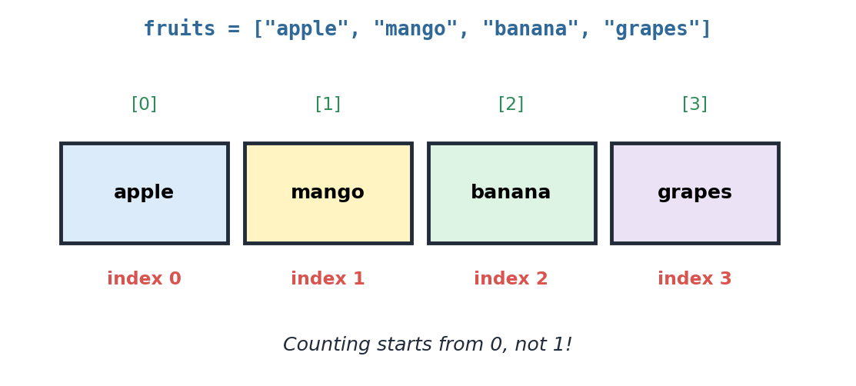
Figure 13.1: Every item has an index starting from 0
Program 23
print(fruits[0])
print(fruits[2])
print(fruits[-1])
OUTPUT
apple
banana
grapes

fruits[-1] means the last item. Negative numbers count from the end.

13.3 Useful List Operations
Task | Code | Result
Add at the end | fruits.append("kiwi") | kiwi added
Insert at a position | fruits.insert(1, "pear") | pear placed at index 1
Remove an item | fruits.remove("mango") | mango removed
Count the items | len(fruits) | Number of items
Sort the list | fruits.sort() | A to Z order
Check if present | "apple" in fruits | True or False

13.4 Looping Through a List
Program 24
colours = ["red", "green", "blue"]
for c in colours:
print("I like", c)
OUTPUT
I like red
I like green
I like blue

☺ Fun Fact
AI programs use lists with millions of numbers to store what they have learned!

★ Key Points
A list holds many values in square brackets.
Index numbers start from 0.
append(), remove(), sort() and len() are handy tools.
A for loop can visit every item in a list.

Chapter 14 Functions: Reusable Mini-Programs

14.1 What is a Function?
A function is a block of code with a name that does a specific job. We write it once and use it many times. We have already used built-in functions such as print(), input() and len(). Now we will make our own!
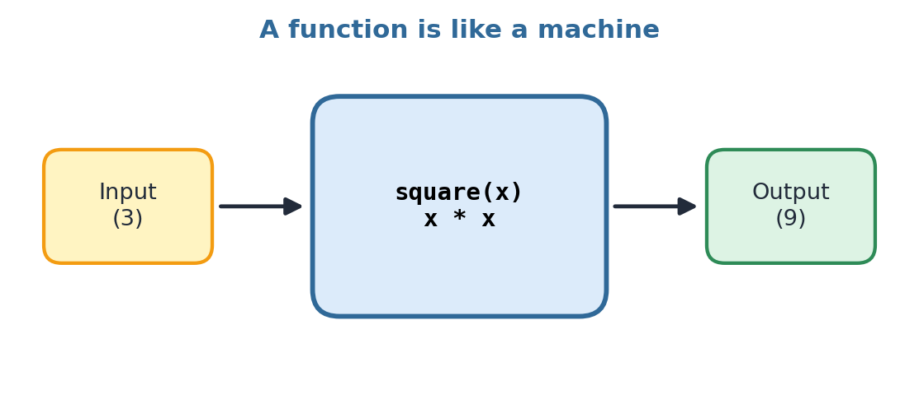
Figure 14.1: A function takes input and gives output

14.2 Creating a Function
Program 25
def greet():
print("Hello!")
print("Welcome to Python class.")

greet()
greet()
OUTPUT
Hello!
Welcome to Python class.
Hello!
Welcome to Python class.

We use the keyword def (short for "define"), then the function name, brackets and a colon. The indented lines form the body. Nothing happens until we call the function by writing its name with brackets.

14.3 Parameters and Return Values
A parameter is a value we pass into a function. A return statement sends a result back.
Program 26
def square(x):
return x * x

print(square(3))
print(square(8))
OUTPUT
9
64

Program 27
def add(a, b):
return a + b

total = add(10, 20)
print("Total is", total)
OUTPUT
Total is 30

14.4 Why Use Functions?
- Reuse: write once, use anywhere.
- Organise: big programs split into small, clear parts.
- Fix easily: if there is a mistake, we correct it in one place.

★ Key Points
def creates a function; we call it by name.
Parameters bring values in; return sends a value out.
Functions make code short and neat.

✎ Try It Yourself
Create a function cube(n) that returns n × n × n. Call it for 2 and 5.

Chapter 15 From Idea to Code

15.1 Every Program Starts with an Idea
Every app, game or website you love started as someone's idea. The title of our notes says "code your first idea". But a good programmer does not just start typing. First they think and plan. A plan makes coding faster and with fewer mistakes.
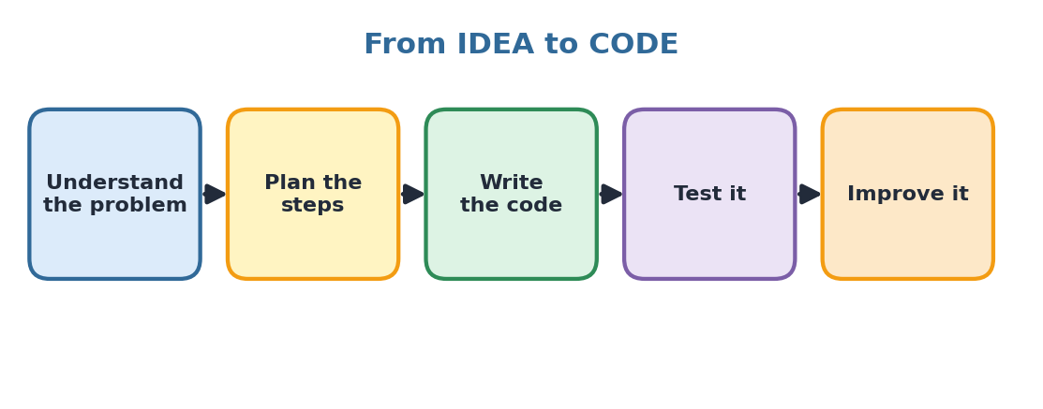
Figure 15.1: Steps to turn an idea into a program
- Understand the problem: What do I want the program to do? What is the input? What should be the output?
- Plan the steps: Write the steps in simple language (an algorithm) or draw a flowchart.
- Write the code: Convert each step into Python.
- Test it: Run it with different inputs. Does it work every time?
- Improve it: Fix bugs, make it neater, add new features.

15.2 Algorithm
An algorithm is a list of clear, step-by-step instructions to solve a problem. A recipe for making tea is an algorithm! Here is an algorithm to find the area of a rectangle:
- Start.
- Ask the user for length.
- Ask the user for breadth.
- Multiply length and breadth to get area.
- Show the area.
- Stop.

15.3 Flowchart
A flowchart shows an algorithm using pictures and arrows. Each shape has a meaning.
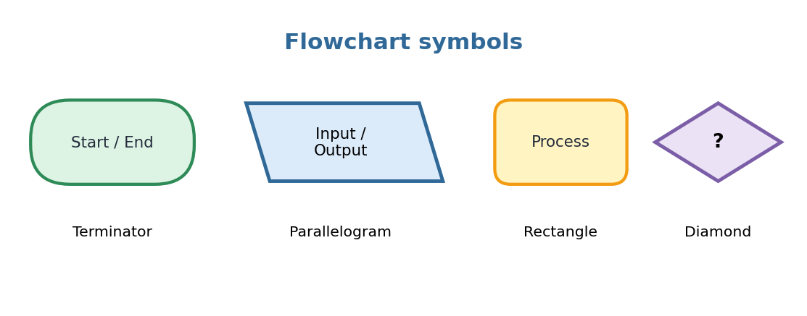
Figure 15.2: Common flowchart symbols

15.4 Turning the Algorithm into Code
Program 28
# Area of a rectangle
length = float(input("Length: "))
breadth = float(input("Breadth: "))
area = length * breadth
print("Area =", area)
OUTPUT
Length: 6
Breadth: 4
Area = 24.0

See how each line of the algorithm became one line of Python? Planning first makes coding easy!

15.5 Example: Idea to Code
Stage | Example: "I want a program to say which of two numbers is bigger"
Idea | Compare two numbers and show the bigger one.
Input | Two numbers a and b
Process | If a > b then a is bigger, else b is bigger
Output | The bigger number

Program 29
a = int(input("First number: "))
b = int(input("Second number: "))
if a > b:
print(a, "is bigger")
elif b > a:
print(b, "is bigger")
else:
print("Both are equal")

★ Key Points
Think and plan before you code.
An algorithm is step-by-step instructions.
A flowchart is a diagram of the algorithm.
Test your program with different inputs.

Chapter 16 Mini Projects: Code Your First Ideas!
It is time to put everything together. Here are some fun programs. Type them, run them, and then change them to make them your own. That is how real coders learn!

Project 1: Friendly Chatbot
A chatbot is a program that talks with people, just like the AI assistants we learned about. This simple one uses input, variables and f-strings.
chatbot.py
print("Bot: Hello! What is your name?")
name = input("You: ")
print(f"Bot: Nice to meet you, {name}!")
print("Bot: How old are you?")
age = int(input("You: "))
print(f"Bot: Next year you will be {age + 1}!")
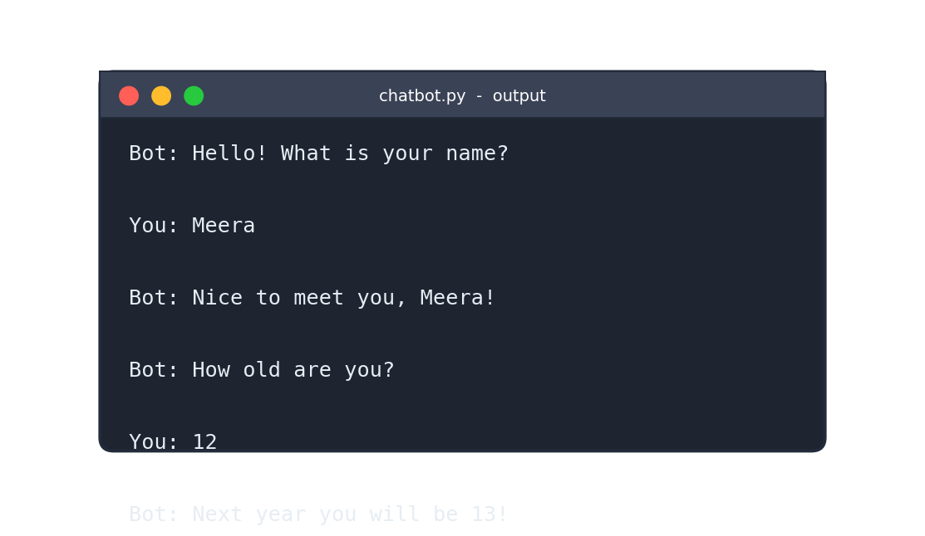
Figure 16.1: Output of the chatbot program

Project 2: Number Guessing Game
The computer keeps a secret number. The player must guess it.
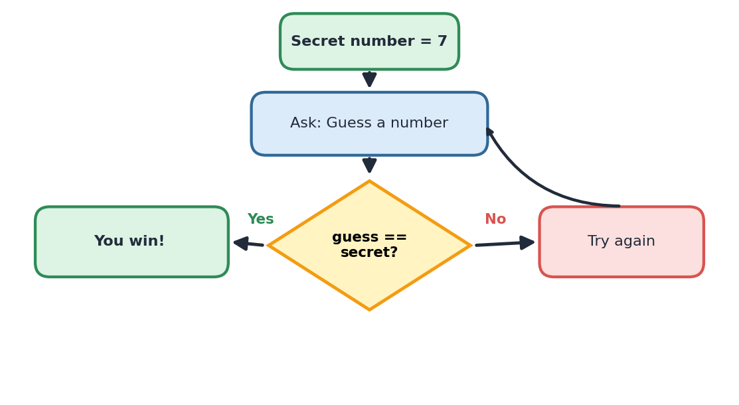
Figure 16.2: Flowchart of the guessing game
guess.py
secret = 7
guess = 0
while guess != secret:
guess = int(input("Guess the number (1-10): "))
if guess < secret:
print("Too small!")
elif guess > secret:
print("Too big!")
print("You won! Great guess!")
OUTPUT
Guess the number (1-10): 3
Too small!
Guess the number (1-10): 9
Too big!
Guess the number (1-10): 7
You won! Great guess!

Project 3: Simple Calculator
calculator.py
a = float(input("First number: "))
b = float(input("Second number: "))
op = input("Choose + - * / : ")

if op == "+":
print("Answer:", a + b)
elif op == "-":
print("Answer:", a - b)
elif op == "*":
print("Answer:", a * b)
elif op == "/":
if b == 0:
print("Cannot divide by zero!")
else:
print("Answer:", a / b)
else:
print("Unknown operator")

Project 4: Quiz Game
quiz.py
score = 0

ans = input("Capital of India? ")
if ans.lower() == "new delhi":
score = score + 1

ans = input("How many days in a week? ")
if ans == "7":
score = score + 1

ans = input("Python is a snake or a language? ")
if ans.lower() == "language":
score = score + 1

print("Your score:", score, "out of 3")
.lower() changes text to small letters, so "New Delhi", "NEW DELHI" and "new delhi" are all accepted.

Project 5: Story Maker
story.py
hero = input("Name a hero: ")
place = input("Name a place: ")
thing = input("Name a magic object: ")

print()
print(f"Once upon a time, {hero} travelled to {place}.")
print(f"There, {hero} found a magical {thing}!")
print("And the adventure began...")

Project 6: Star Pattern
pattern.py
for i in range(1, 6):
print("*" * i)
OUTPUT
*
**
***
****
*****

✎ Try It Yourself
Add a new question to the quiz. Make the guessing game count how many guesses were taken. Invent a project of your own idea!

Chapter 17 Python and AI Working Together

17.1 Why is Python Loved by AI Builders?
Python is the number one language for AI. Scientists use it because it is simple, so they can focus on solving problems instead of fighting with complex rules. It also has powerful ready-made libraries:
Library | What it helps with
NumPy | Fast calculations with numbers
Pandas | Handling tables and data
Matplotlib | Drawing charts and graphs
TensorFlow / PyTorch | Building and training AI models
Turtle | Drawing shapes (great for learners!)

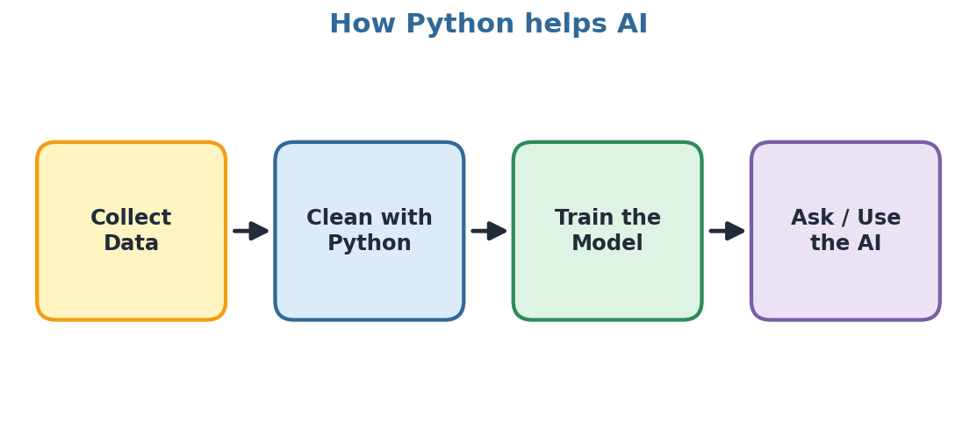
Figure 17.1: Python helps at each step of building AI

17.2 Using Libraries
A library is a collection of ready-made code. We bring it into our program using import.
Program 30
import random

print(random.randint(1, 6)) # a dice roll!

import math
print(math.sqrt(49))
OUTPUT
4 (random: could be 1 to 6)
7.0

17.3 Learning Python with an AI Helper
AI assistants can be wonderful learning partners. You can ask them to explain code, give practice questions or help you find a bug. But remember: you are the coder, AI is the helper.

Good ways to use AI while learning
- Ask: "Explain this code line by line for a Class 7 student."
- Ask: "Give me 5 practice questions on for loops with answers."
- Ask: "Why does this code show a SyntaxError?" and paste your code.
- Ask: "Give me a hint, not the full answer."

Careful habits
- Always run and test the code the AI gives you. It can be wrong!
- Understand every line before using it.
- Try yourself first, then use AI to check or improve.
- Never copy homework answers directly. That does not help your brain grow.

17.4 A Sample Conversation
Prompt and Response
You: Act as a friendly Python teacher. Explain what a
variable is in 3 lines for a Class 7 student.

AI: A variable is like a labelled box in the computer.
It keeps a value, like age = 12. You can change the
value later and use the label to find it.

☺ Fun Fact
Some AI systems can write Python programs from a description. But a human programmer must still check the code, test it and decide whether it is useful and safe.

★ Key Points
Python is the main language for AI.
Libraries save time; use import to bring them in.
Use AI as a helper, check its answers, and keep learning yourself.

Chapter 18 Debugging: Becoming a Bug Detective

18.1 What is a Bug?
A bug is a mistake in a program. Debugging means finding and fixing bugs. The word comes from the 1940s, when engineers once found a real moth stuck inside a giant computer and had to remove it!
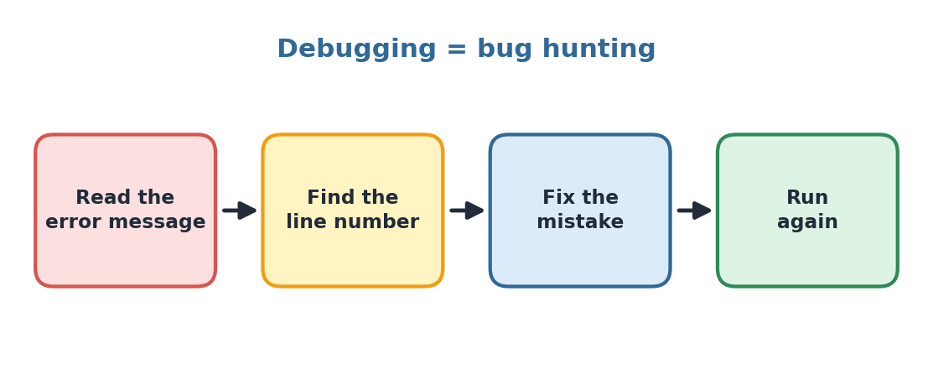
Figure 18.1: The debugging cycle

18.2 Common Mistakes and Fixes
Mistake | Wrong code | Correct code
Missing quote | print("Hi) | print("Hi")
Wrong spelling | pritn("Hi") | print("Hi")
Capital letter | Print("Hi") | print("Hi")
Missing colon | if x > 5 | if x > 5:
No indentation | if x: then print(x) at line start | Indent with 4 spaces
Text + number | "Age" + 12 | "Age" + str(12)
= instead of == | if x = 5: | if x == 5:

18.3 Debugging Tips
- Read the error message. It gives you the line number and the type of error.
- Check the simple things: spelling, brackets, quotes, colons, indentation.
- Use print() to peek. Print variables to see their values while the program runs.
- Test small parts. Run a few lines at a time.
- Take a break. A fresh mind spots mistakes faster. You can also explain the problem to a friend.

18.4 Find the Bug!
Buggy program
name = input("Name: ")
age = input("Age: ")
next_year = age + 1
print("Next year", name, "will be", next_year)
Problem: age is text (from input), so age + 1 causes an error.
Fix: age = int(input("Age: "))
★ Key Points
Bugs are normal. Every coder faces them.
Read errors carefully, then fix one thing at a time.
Use print() to check what is happening inside the program.

✎ Try It Yourself
Debug these: (a) for i in range(3) followed by print(i) (b) x = 5 if x == 5: print("Five") (c) print("Total", 5 + "3")

Chapter 19 Revision, Glossary and Practice

19.1 Chapter Summary
Topic | Remember
Communication | Sender, message, receiver; both must share a language.
AI | Machines doing smart tasks by learning from data.
Prompt | Clear instruction to AI: Role + Task + Details + Format.
Python | Easy, free, powerful language used in AI.
print() | Shows output on screen.
Variables | Named boxes that store values.
Data types | int, float, str, bool
input() | Takes text from the user; convert with int() or float().
Operators | Arithmetic, comparison and logical.
if / elif / else | Make decisions.
Loops | for and while repeat code.
Lists | Store many values; index starts at 0.
Functions | def creates reusable blocks of code.
Debugging | Find and fix errors patiently.

19.2 Glossary
Word | Meaning
Algorithm | Step-by-step instructions to solve a problem
Bug | A mistake in a program
Comment | A note for humans, starting with #
Condition | A question whose answer is True or False
Function | A named block of code that does a job
Index | The position number of an item in a list
Interpreter | Translates and runs Python code line by line
Library | A collection of ready-made code
Loop | Code that repeats
Machine Learning | Computers learning from examples
Prompt | The instruction you give to an AI
String | Text inside quotation marks
Syntax | The grammar rules of a language
Variable | A named place to store a value

19.3 Fill in the Blanks
- The text that we give to an AI is called a ______.
- Python was created by ______.
- The function used to display output is ______.
- The symbol used for comments in Python is ______.
- The data type of 3.14 is ______.
- The ______ loop repeats until its condition becomes False.
- The first item in a list has index ______.
- We create a function using the keyword ______.

19.4 Multiple Choice Questions
- Which of these is a programming language? (a) Windows (b) Python (c) Google (d) Mouse
- What will print("5" + "3") show? (a) 8 (b) 53 (c) Error (d) 15
- Which operator gives the remainder? (a) / (b) // (c) % (d) **
- Which is a valid variable name? (a) 2name (b) my name (c) my_name (d) class-1
- What does range(3) produce? (a) 1, 2, 3 (b) 0, 1, 2 (c) 0, 1, 2, 3 (d) 3
- Which keyword starts a decision? (a) for (b) def (c) if (d) in

19.5 Short Answer Questions
- What is a prompt? Write two tips for writing a good prompt.
- Name any four uses of Python.
- What is the difference between = and == ?
- Why does input() need int() when we want to add numbers?
- What is the difference between a for loop and a while loop?
- What is debugging? Write three debugging tips.
- Why should we check the answers given by AI?

19.6 Predict the Output
Question
print("A", "B")
print(4 * 3)
x = 10
x = x + 5
print(x)
for i in range(3):
print(i * 2)

19.7 Programming Practice
- Write a program to print "Hello" and your name on two lines.
- Ask for two numbers and print their sum, difference and product.
- Check whether a number entered by the user is even or odd.
- Print the numbers from 1 to 20 using a loop.
- Store 5 favourite foods in a list and print each one.
- Create a function that takes a name and prints a greeting.
- Make your own mini project, such as a chatbot, quiz or story maker.

19.8 Answers
Section | Answers
Fill in the blanks | 1) prompt 2) Guido van Rossum 3) print() 4) # 5) float 6) while 7) 0 8) def
MCQs | 1) b 2) b 3) c 4) c 5) b 6) c
Predict the output | A B / 12 / 15 / 0 / 2 / 4

♥ Final Words
You have just taken your first step into the world of coding and AI. Keep practising a little every day, stay curious, ask good questions and never fear mistakes. Happy coding!

